INQUIRY

Screen Shot:
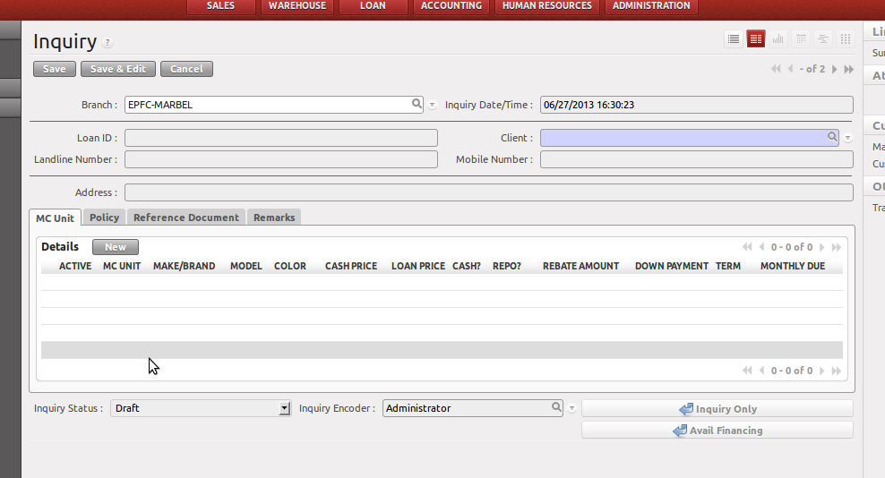
Required Modules:
Client Information - Loan >> Client
Product Information - Loan >> Warehouse
Rebate - Loan >> Configurations >> Financing >> Rebates
Terms - Loan >> Configurations >> Financing >> Payment Terms
Collector – Loan >> Loan Configurations >> Localization >> Collectors

How to Use:
Step 1: Fill-in the Client field.
Step 2: To add details for inquiries, click the New Button shown in the picture below.
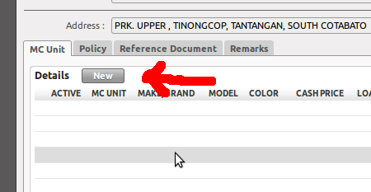
When NEW button is clicked, the screen shot below will appear.

Step 3: Fill-in the Amortization Details

MC Unit Details:
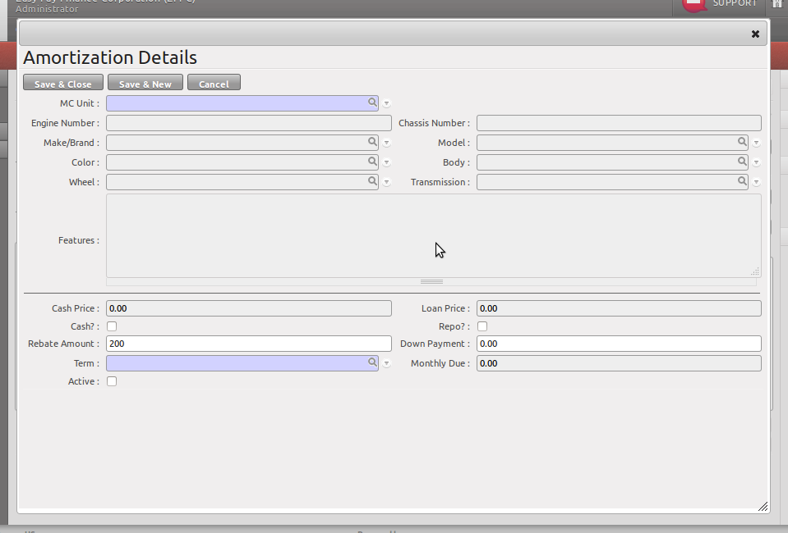
Step 4: If MC Unit Details has multiple records,
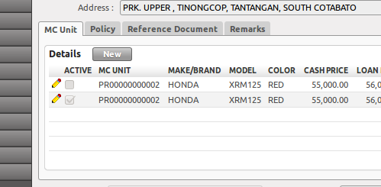
edit the ACTIVE field by checking it. The active record will be used on Step 5.

Step 5: Inquiry Only and Avail Financing

If the customer will Inquire only and do not wish to avail financing, click the INQUIRE ONLY button shown below.

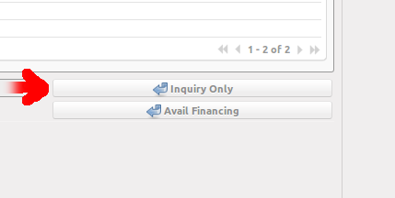
If the customer wishes to avail financing, click the AVAIL FINANCING button.

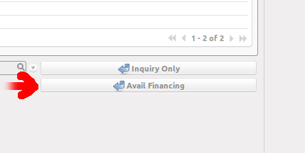
This will create a new record to LOAN APPLICATION module.

Validations:
    - A user can only edit the inquiries for their branch.
    - Will not proceed if no active record in MC Unit Details.
    - Will not proceed if 'Cash?' is checked.
    - Will not proceed if the Barangay Code of the Client has no assigned collector.
    - Downpayment should not be less than the specified amount in the product information.
    - Edit is allowed only for the records with STATE is DRAFT.

